Vivekanand Education Society Polytechnic

**INDUSTRIAL TRAINING REPORT**

**(22049)**

**(Internship)**

**Academic Year:** 2020 -2021 **Program :** CO5I.

**Semester:** Fifth .

**Name of Industry:** Aerus Infotech .

**Industry Mentor:** Mr. Vilas Sangre.

**Institute Mentor:** Prof. Menna Talele.

**Submitted by:** Mr. Gaurav Amarnani.



**MAHARASHTRA STATE BOARD OF TECHNICAL EDUCATION**

# Certificate of Completion

## Of Industrial Training

**(By respective Head of Institute & Head of the Department)**

This is to certify that **Mr. Gaurav Sanjay Amarnani.** With Enrollment No.1800040181has successfully completed Industrial Training (22049) in **Aerus Infotech**  from **08Th June, 2020 to 11Th July 2020**  or practical fulfilment towards Completion of Diploma in **Computer Engineering** from **Vivekanand Education Society Polytechnic** Institute code **0004**.

**Signature Signature**

**Seal of Institution**

**Head of the Department Head of the Department**



**To,**

**The Principal**

**Vivekanand Education Society Polytechnic**

**INTERNSHIP COMMPLETION LETTER**

Dear Sir

This is to certify that Mr. Gaurav Sanjay Amarnani student of Diploma Computer Engineering studying in semester IV of your esteemed Institute has successfully completed the Internship of Web Development from 5 June 2020 to 05 July 2020 as the syllabus during the period he was assigned and has completed the tasks as mentioned below:

1. Web Designing
2. Web Development

Yours Sincerely,

For **Aerus InfoTech.**



**Received & Accepted**

**Mrs Manjusha Patil**

(Managing Director)

**Authorized Signatory**

## Abstract

The key to having successful and fully functional web applications is in their communication with

the user. It is of no surprise that human/machine interaction is a popular topic of research and

development, as is the main goal at the research centre for Aerus Infotech, where I had the honour to

spend my first training period.

During the training period we were exposed to the modern side of Graphics and Designing, which

was completely different from our perspective. We were taught web technologies such as HTML,

CSS, Bootstrap, JavaScript, jQuery, Angular Js. As challenges are necessary to discover our

strengthens, not every task or assignment given to me was a piece of cake at first, but with the

support and guidance of our trainer,

It gave me the knowledge of important principles like time management, resource management and

team spirit with a practical experience. It gave me the in depth knowledge of the work-culture of the

software world or to say the IT world.

I gained practical experience of working on web development projects, how they are managed by

different terms and condition, testing on webpage.

Gained an effective knowledge of the powerful features of HTML, CSS, BOOTSTRAP and

developed skills for creating simple and attractive webpage with different styling. And also learned

how to make dynamic web pages using JavaScript , jQuery and Angular Js

## INDEX

**Academic year: 2019-20 Name of the faculty:**

**Program code: CO5I Course & course code: Name of the candidate: Mr Gaurav Roll No: 21.**

**Amarnani.**

**Enrollment No. 1800040181.**

|  |  |  |
| --- | --- | --- |
| **Sr.No** | **Content** | **Page No.** |
| 1 | Organization Structure and Hierarchy | 1 |
| 2 | Introduction of the Industry | 2 |
| 3 | Hardware and Software Resources | 4 |
| 4 | Research and Development and Working Process | 5 |
| 5 | Testing and Marketing of Product | 6 |
| 6 | Hardware and Software Platform Handling | 7 |
| 7 | Safety Procedure Followed | 8 |
| 8 | Practical Experience, New Things Learnt | 9 |
| 9 | Project Description | 10 |
| 10 | Challenges Encountered | 23 |

## Acknowledgment

First I would like to thank, the Director and supervisor of Aerus Infotech, Thane for giving me the

opportunity to do an internship within the organization

I would like to thank all those people who helped in the successful completion of the industrial

training (summer internship).

I would like to thank Mr. Vikrant Joshi, Principal of V.E.S Polytechnic for his immense support and

motivation.

I would like to thank Mr. Avinash Dangwani, IC, Head of Department, Computer Engineering of

V.E.S Polytechnic, for his guidance. I am wholeheartedly thankful to him for giving me his valuable

time for providing a systematic way of completing the projects in time.

I would like to thank Mr. Mahadeo Narlawar, our industrial mentor for her guidance. I have learnt

so many things from her and she motivated and strengthened my confidence in doing this internship.

I express my deepest gratitude for her valuable suggestions and constant motivation that greatly

helped the internship to successfully complete. Throughout the internship, her useful suggestions,

constant encouragement has given us a right direction to shape our learning.

During my internship experience with Mrs. Vina Ma’am , I was able to develop my different skills.

I particularly found many experiences to be useful in improving my skill. Although I found

experience]to be challenging, I found it to be valuable in developing my skill.

# CHAPTER 01: ORGANIZATIONAL STRUCTURE

# AERUS INFOTECH

# 

# CHAPTER 02: INTRODUCTION OF INDUSTRY

Aerus InfoTech is dynamic and creative design services and is recognized as one of the fastest growing and most experienced Web Hosting and Web Application Development Company. The company is owned and runned by Mr Vilas Sangre since 2014 While we have successfully delivered numerous projects in the areas of Web Hosting, Web designing, Online application developed While we innovation and numerous projects in the areas of Web Hosting, Web-designing, Online application development, Internet Marketing, Digital Marketing, Online Branding, E-commerce Solutions, and Software Development, we have also gathered vast knowledge base through continuous innovation and learning. Internet Marketing, Digital Marketing, Online Branding, E-commerce Solutions, and Software Development, we have also gathered vast knowledge base through continuous innovation and learning.

**Team of Aerus InfoTech**

Mr Vilas Sangre : Founder of InfoTech

Mrs Manjusha Patil : CEO of the InfoTech

Mrs Neelam Bakshi : Center Head and OPS Manager

Ms Pragati Bhandalkar : Software Developer

Ms Nayna Sonone : Java and Android-Developer

Mrs Chaityana Sujithkumar : Java Developer

Mrs Monika Salla : Web Developer

Mr Darpan Dhuri : Java Developer

Mr Ashok Bahir : UI/UX Developer.

Mr Vishal Patil : Java Developer

Ms Jui Varvatkar : Software Developer

# Services:

# Web Development

# We bring years of experience on board in developing web based applications to meet both the business and technical requirements of a project. Web application development is the process and practice of developing web applications.Just as with a traditional desktop application, web applications have varying levels of risk. A personal home page is much less risky than, for example, a stock trading web site. For some projects security, software bugs, etc. are major issues. If time to market, or technical complexity is a concern, documentation, test planning, change control, requirements analysis, architectural description and formal design and construction practices can mitigate risk.

# ERP Application

# Companies grow 35% faster with better data and we provide Customized, Cost Effective and Web Based Enterprise Resource Planning Software. With many years of experience in developing business software systems for organizations of all sizes, we develop and deliver tailor-made software solution for multiple segments. Whilst these apps will work as per your need and convenience. You can also build a hybrid solution that brings together a unique combination of ready-made and tailored software apps, depending upon your business needs.

# Cloud Development

# With a dedicated team of experienced development professionals, we build the high- end Cloud Computing based Applications.

# Mobile App Development

# Dynamic mobile applications are designed to increase business productivity & application efficiency. We understand that many of our clients wish to follow a particular budget line and yes we do respect this. Thus, we create such exact scope that wouldn't compromise customer needs and will also work on any budget margin.

# Research & Development

# Our team are experts at delivering high quality, high-end Research & Development solutions.

# CHAPTER 03: RESOURCES USED

In today’s day and age, computers have become a part and parcel of our lives. We can find them everywhere around us. They have a variety of significant and important applications in several different fields, including corporate industries. The operating system of your computer is an important factor to be considered when you install any software. It is the base program, which is designed to manage the hardware and software resources on your computer. Before you install software, the first important step is to check the configuration of your computer, and the system requirements of the software. The configuration of your computer must match the requirements of the software to be installed. Most computer software and hardware installation can easily be carried out with the help of some basic knowledge of computers.

**HARDWARE USED:**

Laptop.

**Configuration**

1. Company : Dell.

2. Processor : i5 , 8th Generation.

3. RAM : 8 GB.

4. OS: Windows10

5. Hard Disk : 2 TB.

6. Graphics : 4 GB AMD Radeon

7. Screen Size : 15.6 inches.

**SOFTWARE USED:**

# Brackets is a free source-code editor made by Microsoft for Windows, Linux and macOS. Features include support for debugging, syntax highlighting, intelligent code completion, snippets, code refactoring, and embedded Git.

# Open source Code Editor : Brackets

# 2. Web Browser : Google Chrome. Screen Size: 15.6 inches

# CHAPTER 04 : RESEARCH & DEVELOPMENT

### **RESEARCH:**

### 1. Researched how Front end and Back end of website works.

### 2. Researched about the various features of the web designing

### 3. Researched about the software to be used i.e. Visual Studio Code and it’s installation

### 4. Researched and learned how to use different elements of HTML.

### 5. Researched and understood how to use HTML and CSS and how it makes building websites attractive and efficient.

### 6. Researched about JavaScript, jQuery, and Angular JS and learned about its different properties.

### 7. Learned to perform DOM manipulation and how to use it.

### 8. Researched and understood how to use various tools and how it makes building websites easier and a lot more faster

**Development:**

1. Through this research and development phase, we came to know about how organization works.

2. Developed different resume templates for a specific company project of generation of user resumes

3. Developed habit of getting the work done in short time period with less complexity and fewer lines of code.

4. Developed websites such as Grocery Store (E-commerce store), Doctor’s Website and Instructor Website

**Working Process:**

1. Discussed about the resume template with the trainer.

2. Then we downloaded a software that was easily used with more features i.e. Visual Studio Code.

3. Deciding the layout of the design and getting it verified by the trainer.

4. Preparing the basic HTML file of the website for rough layout.

5. Started with the concept of CSS , Bootstrap

6. Secondly we created templates for Doctor Website and Instructor Page

7. We faced a lots problem but they were resolved by ourtrainer

8. We started to learn basic concept of JS , Jquery and Angular JS with its properties.

9. Discussed how to carry out the tasks.

10.Created the template in given time and presented

# CHAPTER 05 : TESTING OF PRODUCT

**Testing Tool:** w3validation.com

**Website:** [https://validator.w3.org](https://validator.w3.org/#validate_by_uri) .

This tool is very much helpful while developing website it provide three option for the checking the error and those are:

1. Validate by URI.
2. Validate by file upload.
3. Validate by direct input
4. Testing the size and identification of an elements.
5. Tested the spacing of component.

3. Tested for performance, security and usability

4. Tested the color scheme used for the project.

5. Tested whether all the elements work properly on all browsers.

6. Tested the alignment of all the elements.

7. Used various tools for making the test easier

# CHAPTER 06: SOFTWARE-HARDWARE HANDLING PROCESS

### **Software Used**

1. Brackets.

### **Brackets:**

### Brackets (Installation) Visual Studio Code is a lightweight but powerful source code editor which runs on your desktop and is available for Windows, macOS and Linux. It comes with built-in support for JavaScript, TypeScript and Node.js and has a rich ecosystem of extensions for other languages (such as C++, C#, Java, Python, PHP, Go) and runtimes (such as .NET and Unity)

### **Steps to Install:**

1. Open Google Chrome or any web browser
2. Type brackets.io in the URL section
3. Select the Operating System you want to install for.
4. For windows select the 32 bit or 64 bit version.
5. Click install.
6. Do the setup accept the license agreement.
7. Install the Emmet plugin
8. Install other plugins and themes.

# CHAPTER 07: SAFETY PROCEDURES FOLLOWED

1. Precaution was taken to install To Default Directory To Avoid Problems

2. Precaution was taken that the software downloaded is genuine and from the official site and not the pirated one to protect the intellectual property rights.

3. Precaution was taken that the software downloaded does not incur any malfunctioning or virus in the pc.

4. The anti-virus software was always kept up-to-date and regular threat checks were done.

5. Created specific folder to keep all the projects and assignment in that same folder.

6. Before closing software make sure that all the files are stored properly.

7. Saved the file before closing software.

8. Stored the copy of project and assignment in Drive (Backup) so that we can access it from anywhere or in case of loss of data.

# CHAPTER 08: PRACTICAL EXPERIENCE & NEW THINGS LEARNED

### **PRACTICAL EXPERIENCE:**

1. Gained experience about how the industry functions.

2. Gained experience about how different departments work together in a team to make a product.

3. Understood the importance of team work and how it results intosmooth functioning of a company.

4. Gained experience of the on field work-culture of the software industry and how projects are developed starting from dealing with the clients to testing and maintenance of the product

### **NEW THINGS LEARNED**

1. Learned about the proper management of time for a particular project.

2. Experienced how important it is to finish the project on time and deploy it to the client.

3. Learnt to complete work or before the submission day, se that we can check or go-through the entire project and verify that everything is correct.

4. While developing a project, It basically taught us how to plan, schedule , monitor and control the time for completing it successfully.

**Resource Management:**

1. Learned about how to manage the resources properly and how to make the perfect use of each employees specific quality.

2. The efficient use of the manpower.

3. Improved communication and presentation skills.

4. Learned to handle errors (undesired output)

### TIME MANAGEMENT

1. Learned about the proper management of time for a particular project.
2. From this training we learned that how to follow Dead-lines.
3. Experienced how important it is to finish the project on time and deploy it to the client.

### RESOURCE MANAGEMENT

1. Learned about how to manage the resources properly and how to make the perfect use of each employee specific quality.
2. Learned about the efficient use of the manpower and team-spirit.
3. Learned about how efficiently manage the available resources.

**CHAPTER 09: SHORT DESCRIPTION OF PROJECT**

### PROJECT 1:

### The assignment was to develop a Resume Template based on the given layout from the trainer. This Resume template was developed using HTML and CSS. Few images of the Template:

### PROJECT 2:

In this assignment we had assigned to make Doctor page where tutor (hospital management) can make quiz and upload study material or can enroll for various schedule. We had made this website by using BOOTSTRAP LANDING PAGE.

### PROJECT 3:

In this assignment we had been assigned to make a Website of our own choice by using languages like HTML CSS JavaScript. So we made a Website which provides information about the personalities in the world. There are a total of 16 personalities based on our natural behavior like being introverted or extroverted , making decisions through heart or brain. We provide all the info related to such personalities and one can even take a test to find out the personality of oneself. You will know everything once you see the screenshots below.

### PROJECT 1: The assignment was to develop a Resume Template based on the given layout from the trainer. This Resume template was developed using HTML and CSS. Few images of the Template:

### Screenshots of Project1:

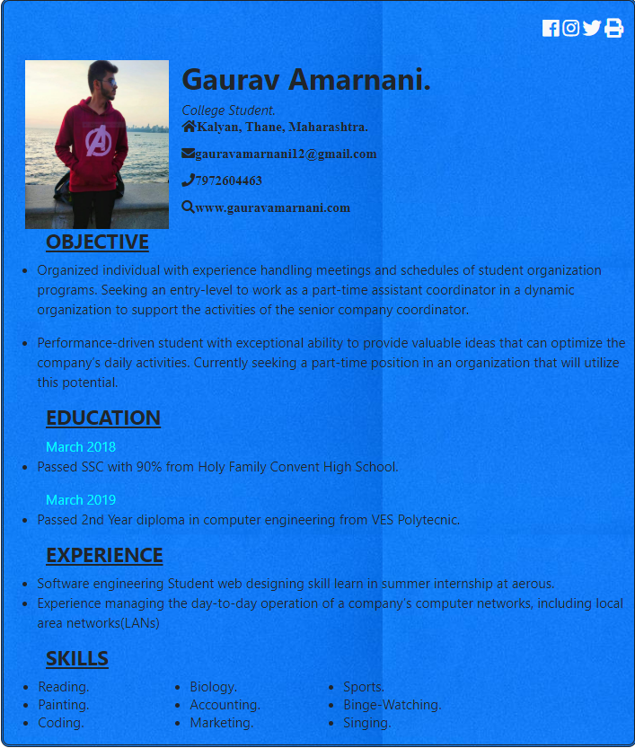

PROJECT 2:

In this assignment we had assigned to make Doctor page where tutor (hospital management) can make quiz and upload study material or can enroll for various scheldue. We had made this website by using BOOTSTRAP LANDING PAGE.

### Screenshots of Project2:

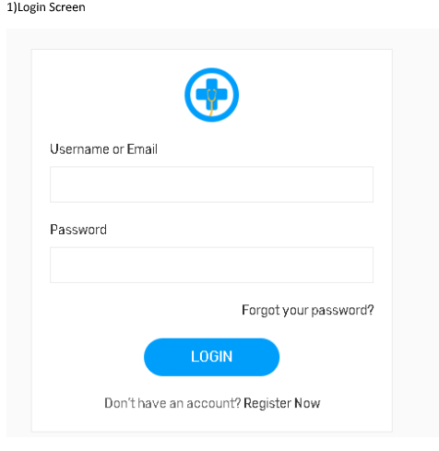



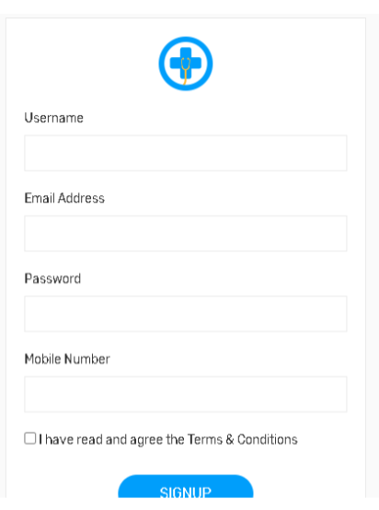

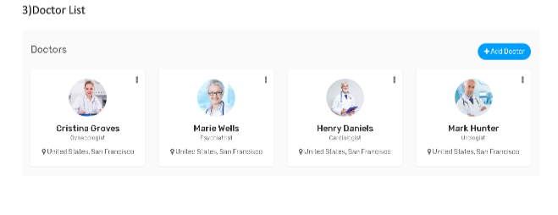

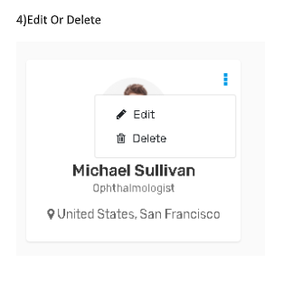

5) Patient List

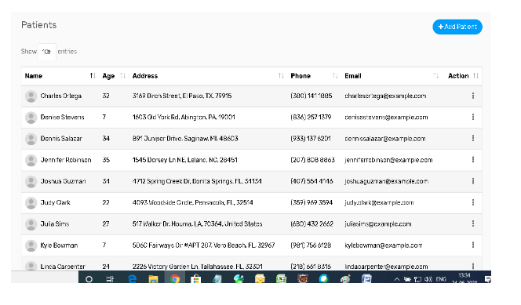

6) Add Patient

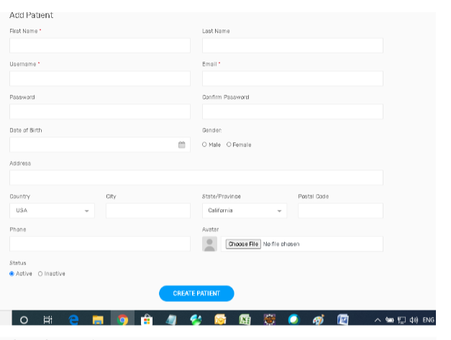

7) Appoints

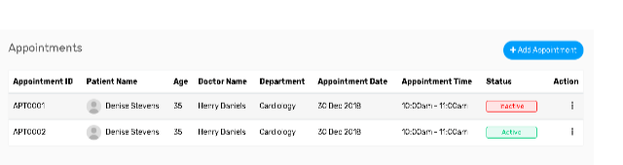

8) Add Appointment

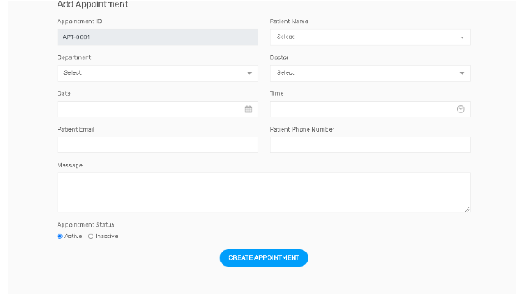

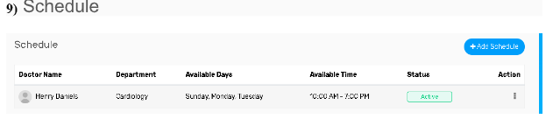

10)Add Schedule

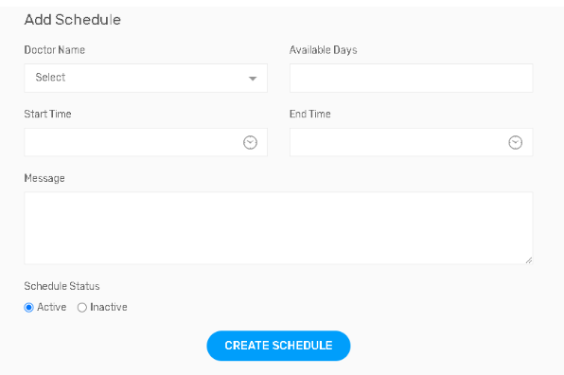

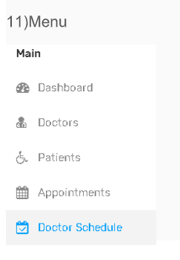

Project 3

In this assignment we had been assigned to make a Website of our own choice by using languages like HTML CSS JavaScript. So we made a Website which provides information about the personalities in the world. There are a total of 16 personalities based on our natural behavior like being introverted or extroverted , making decisions through heart or brain. We provide all the info related to such personalities and one can even take a test to find out the personality of oneself. You will know everything once you see the screenshots below.

Screenshot of Website :

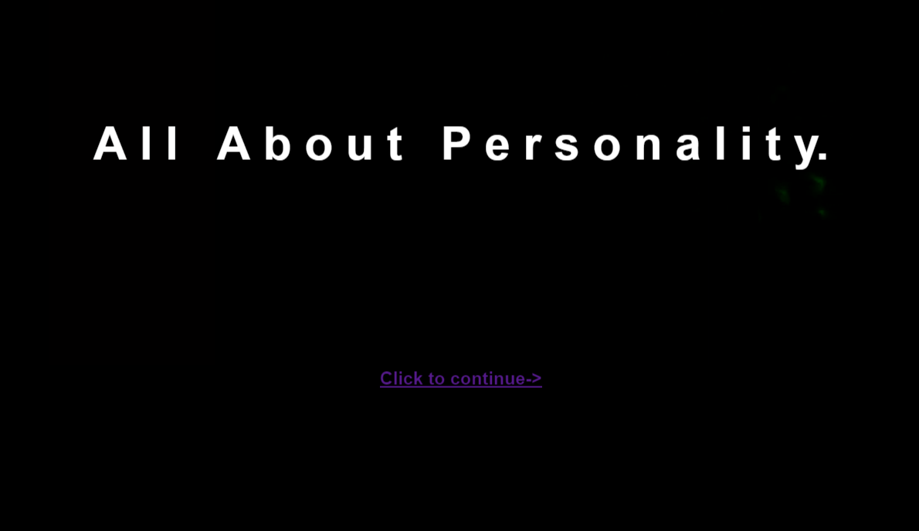

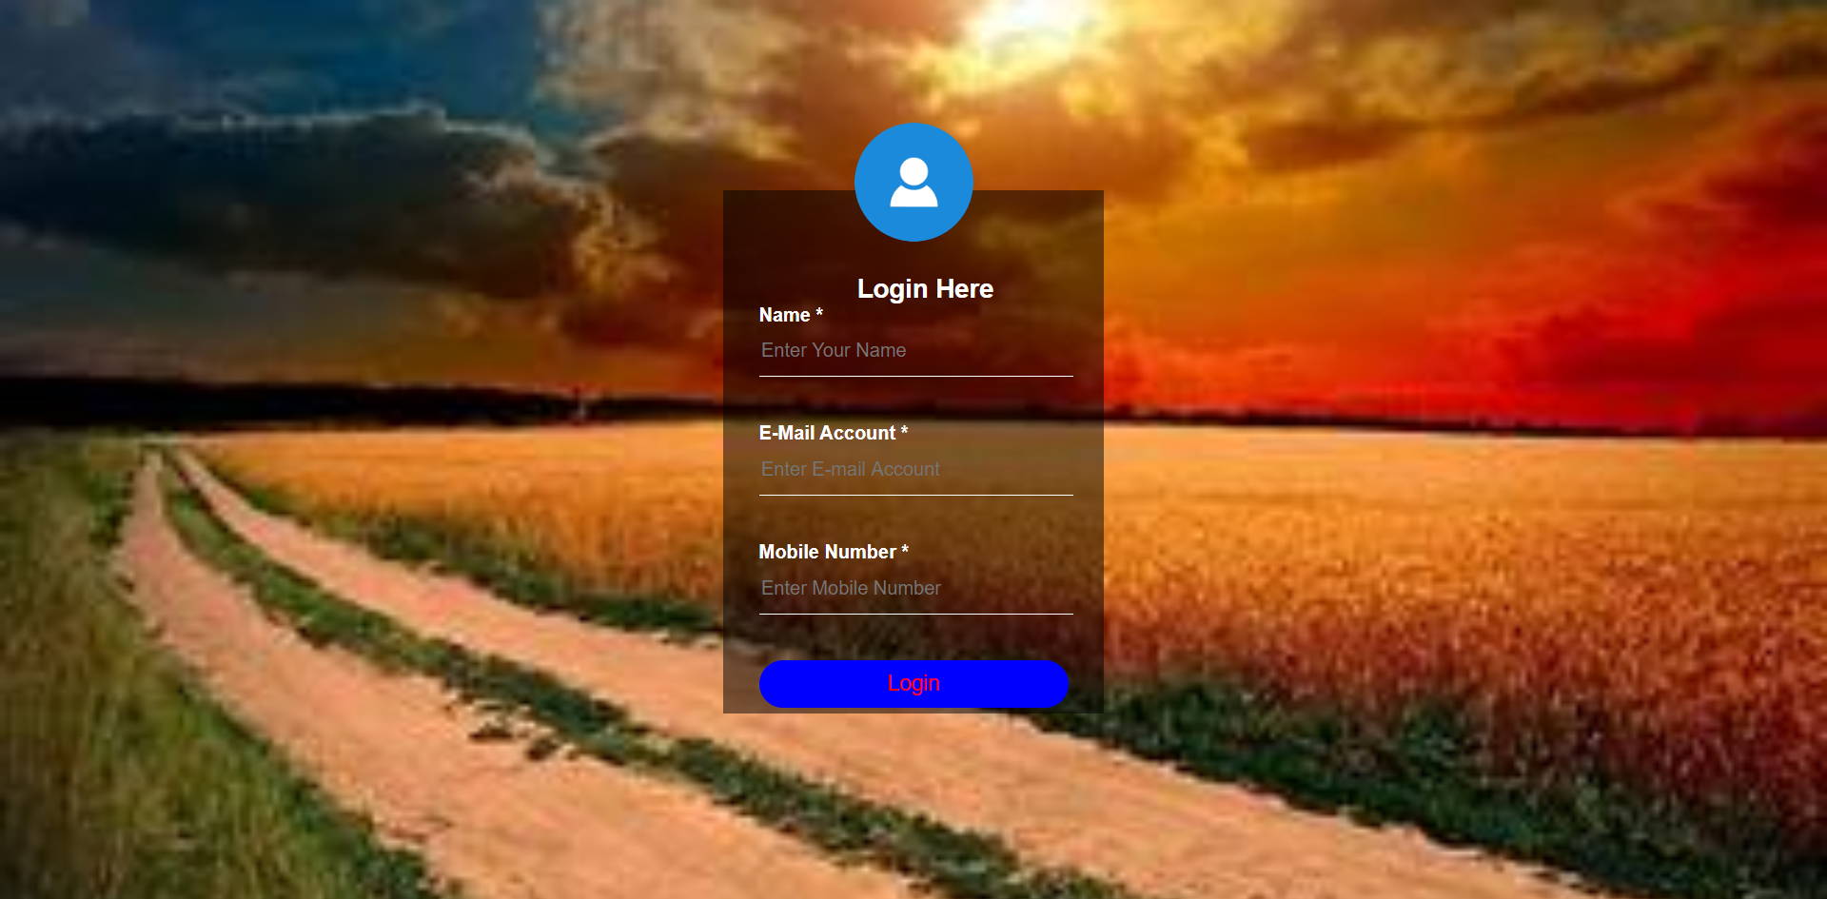

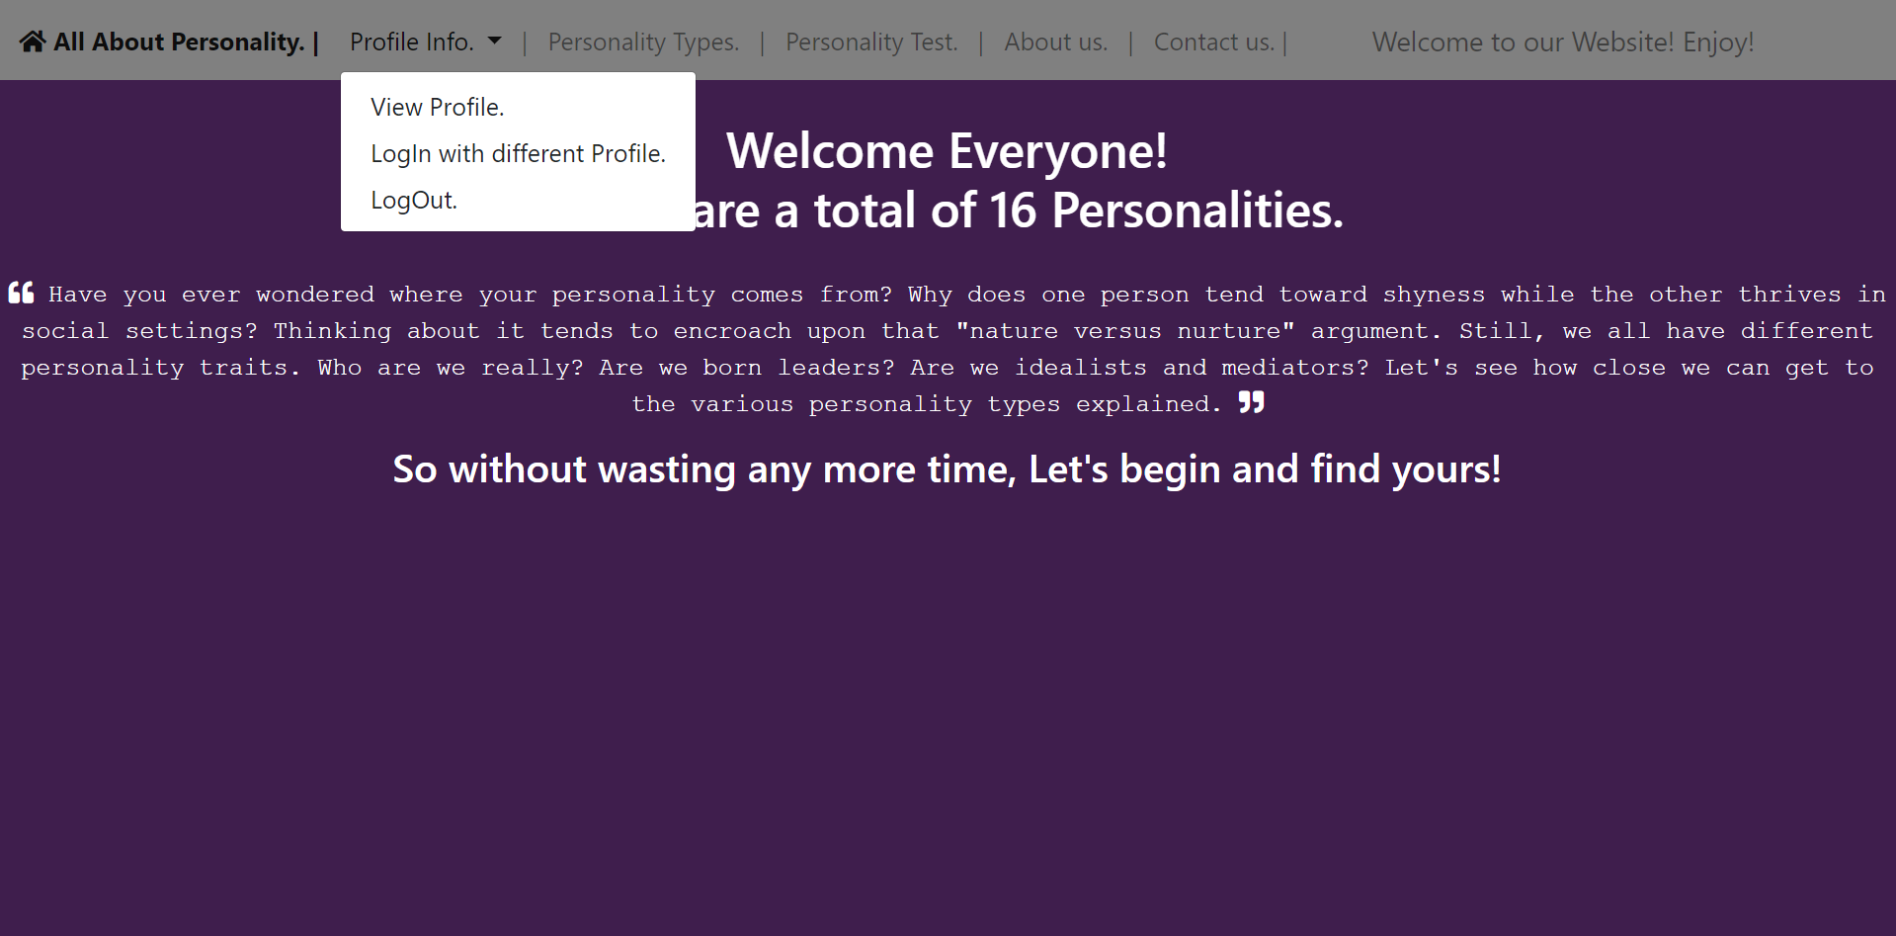

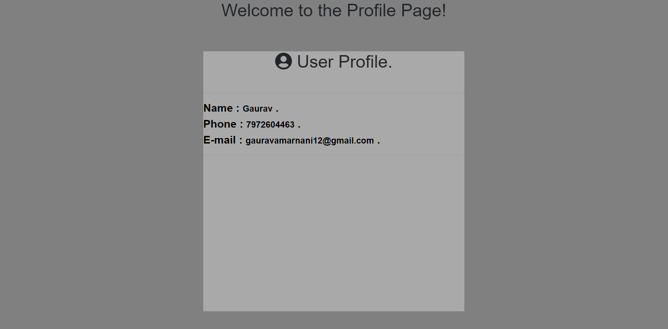

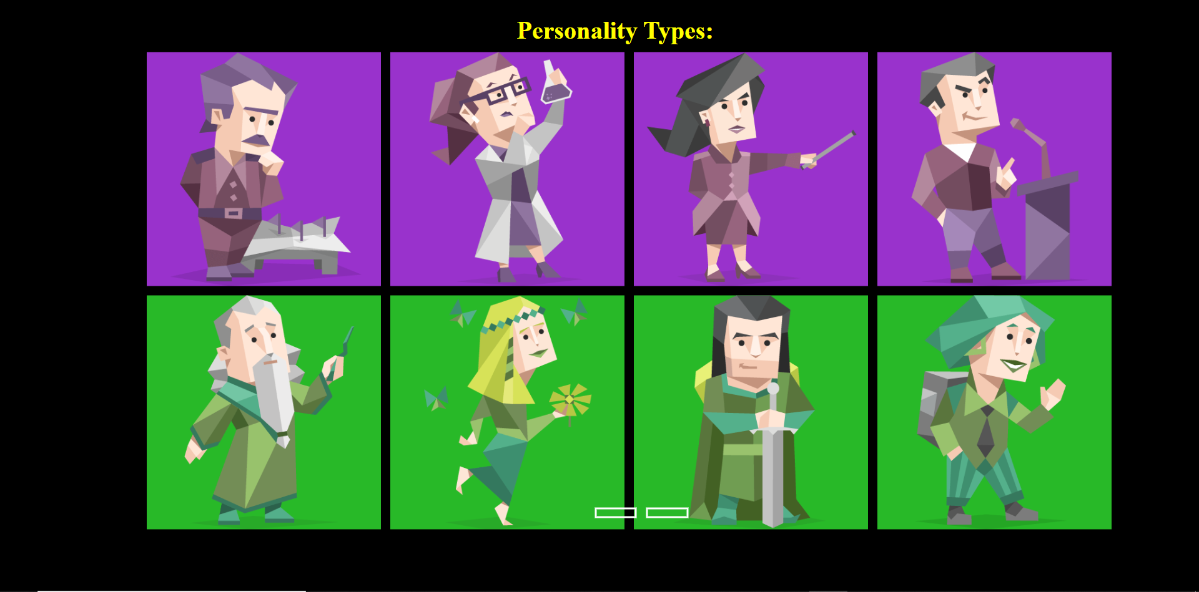

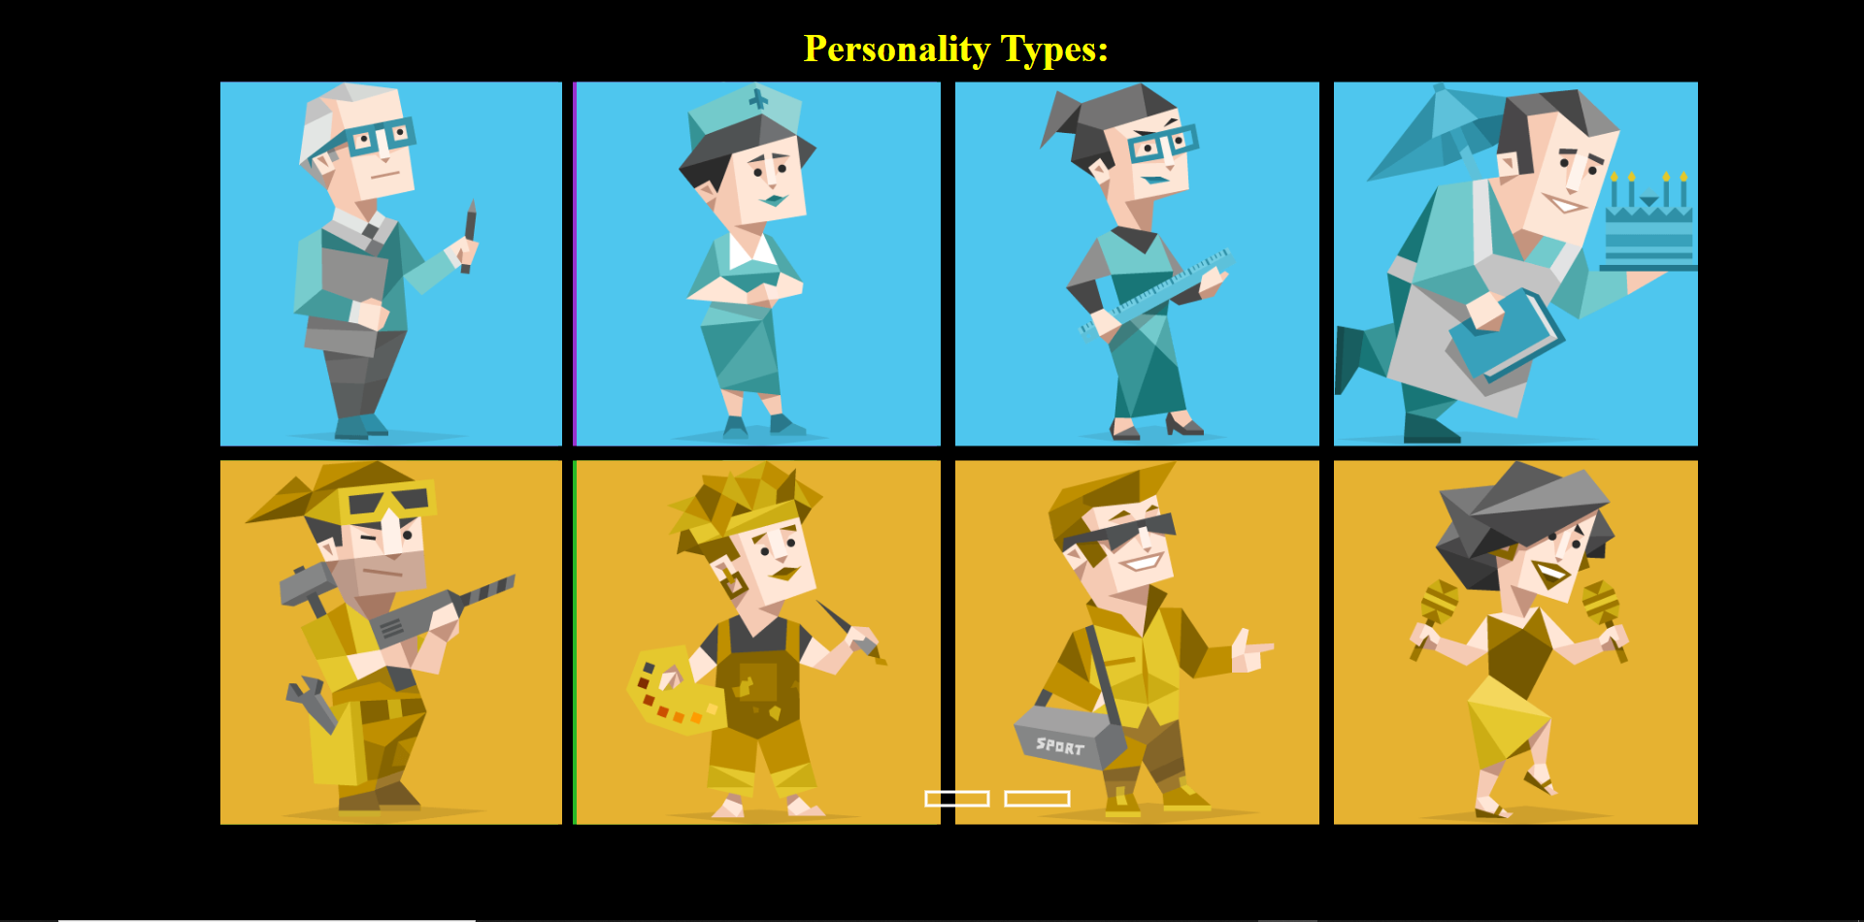

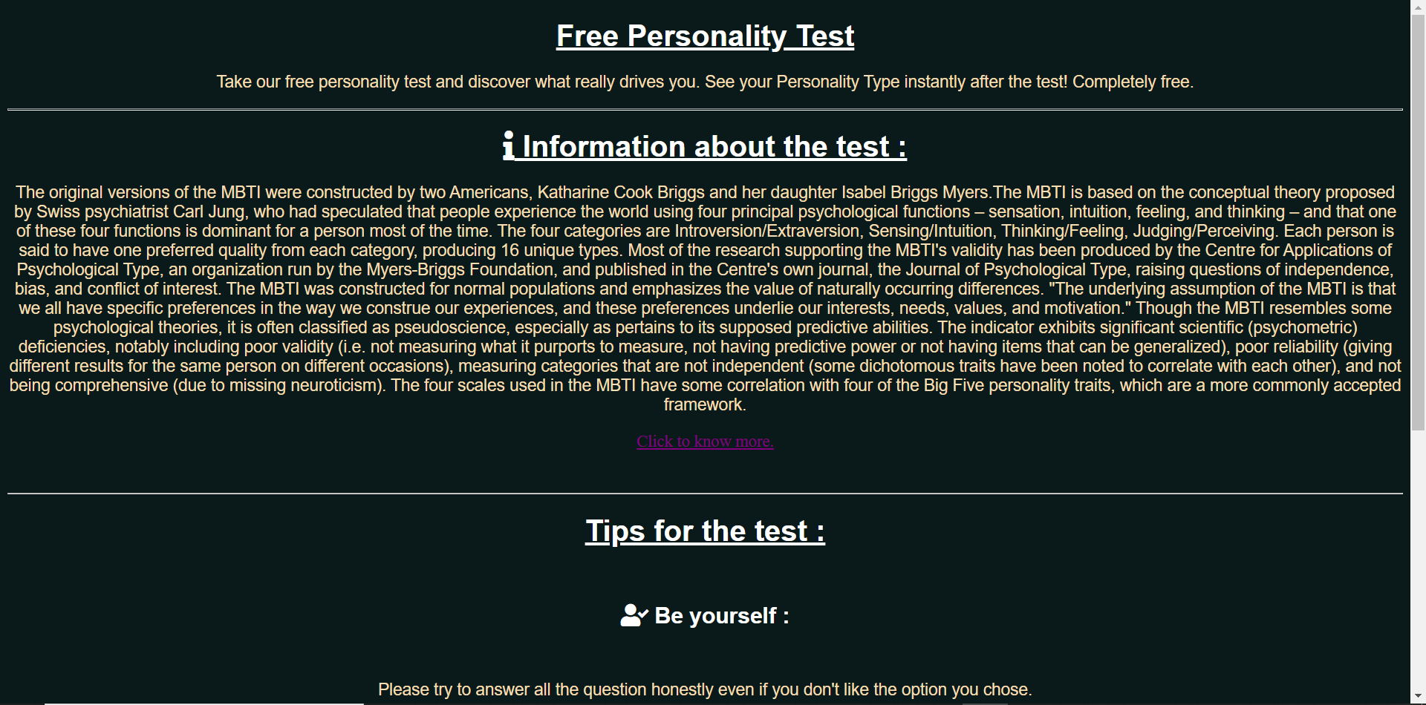

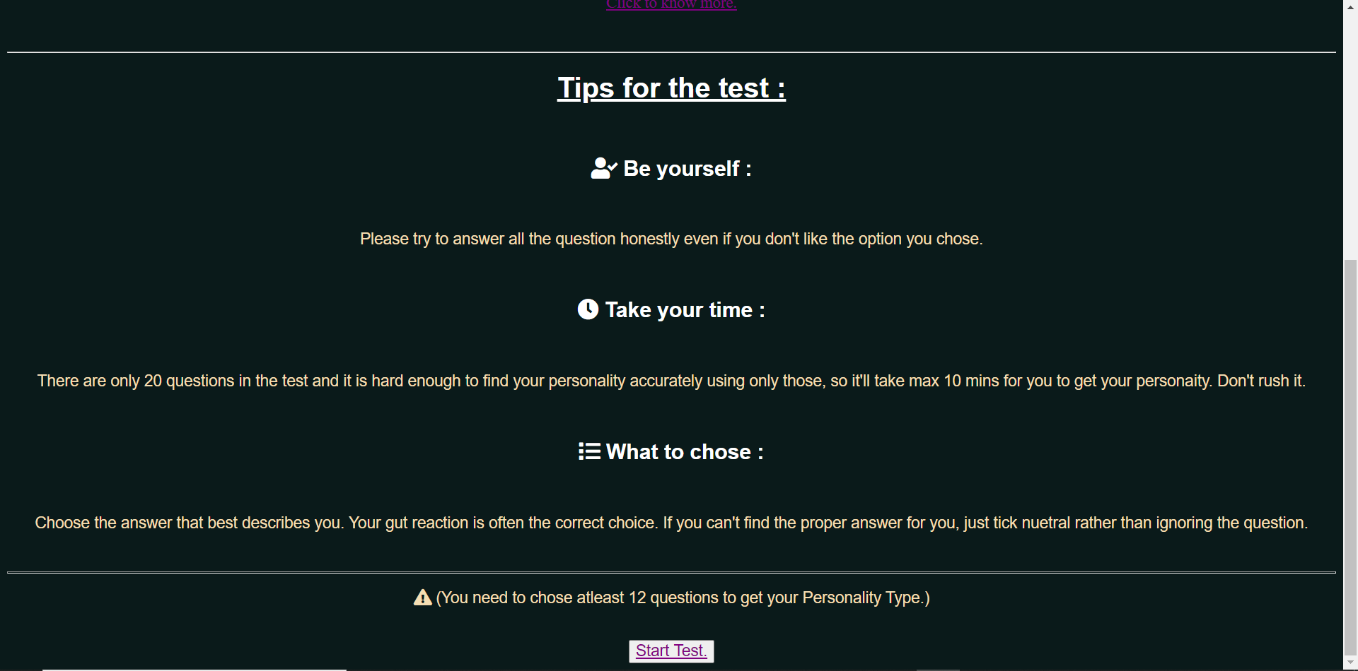

# 

# 

# 

# 

# Note : In the above screenshots , many of them have animations such as in the index page which is the first page of this website have a colorful smoke animations as the letters “All About Personality” appear in accordance to it by using the span element of html. Other animations can be too observed in the Personality Types page too.

# CHAPTER 10 : CHALLENGING EXPERIENCES

1. The first challenge was how to be comfortable with the company and teachers as they were new .
2. The another was to be confident with learning and capable to give answers to the teacher.
3. Making notes of training teaching us on the same day was also a challenging part, as we have to do daily practice along with revision.
4. The first assignment on HTML and CSS was a bit challenging as that was my very first hands on experience on assignment in the industry world. After successful completion of the first assignment and also after satisfaction of the trainer I gained a bit confidence.
5. The first assignment on BOOTSTRAP was a bit challenging as that was my very first hands on experience on in assignment in the industry world. After successful completion of the first assignment and also after satisfaction of the supervisor, I gained a bit confidence
6. Whenever we start a new topic it was difficult to understand the topic at the starting
7. DOM manipulation was also difficult and interesting, but with the help of trainer it became easier to understand.

8. Last but not least the main challenge was the project using each and every tool with best format and design.

## References:

### For the Website making

<https://validator.w3.org/>

<http://www.royalryfashion.com/>

<https://materializecss.com/>

<https://fontawesome.com/>

<https://www.flaticon.com/>

[https://paletton.com/#uid=1000u0kllllaFw0g0qFqFg0w0aF](https://paletton.com/#uid%3D1000u0kllllaFw0g0qFqFg0w0aF)

### For the new designs of Product

<https://in.pinterest.com/>